Online Survey and F2F Consultation Analysis: An Ordinance for the Creation of a Cycling Board Advisory
Executive Summary:
Pasig LGU and Pasig transport, in partnership with Makati Business Club under the Digital Democracy project, conducted an online and public conversation with biking communities to discuss the proposed cycling advisory board.
After the data collection process from both online and face-to-face setup, the gathered data (textual and audio) has undergone a data-science and Natural Language Processing (NLP) approach to analyze and gain insights from the discourse. The online data comprises 36 responses from Oct 19, 2022 – Nov 8, 2022, while 36 total participants joined the face-to-face conversation on Nov 6, 2022.
In the analysis of both textual and audio data, top themes were extracted from the notes, comments, and recommendations of the participants for each article using the Gibbs Sampling Dirichlet Multinomial Mixture (GDSMM), a thematic analysis technique. There are (7) articles each with different sections in the proposed cycling advisory board. Also, (4) underlying themes were observed from the other comments of the participants.
- Bikes lanes are not properly utilized.
- Bikes cones are stolen and trashed
- Bike lane problem in Brgy. San Miguel
- Accessibility of the bikes to PWD
Backgrounds of The Survey:
Pasig LGU and Pasig transport conducted an online and face-to-face consultation with local biking communities to discuss the public cycling advisory board. The discussion will help improve the document supporting the proposed public cycling advisory board.
Objectives of the Online and Public Discourse:
- To know the concerns of the biking communities about bike lanes and the public advisory board
- To improve the documentation of the proposed public cycling advisory board
- To identify which part of the document should be altered for improvement
- Highlight and compare the answers from the online respondents and the public respondents

Methodology:
Pasig City conducted an online and face-to-face discourse with local biking communities. Below is the high-level flow of the feedback collection and analysis process.
Feedback Collection Process and Instruments
In the collection process, (2) separate approaches were employed, an online survey and a face-to-face public conversation. In the online approach, the primary collection tool used was the website (mbc.com.ph), wherein the respondents answered a survey form consisting of (2) sections: demographics and open-ended questions which ask for comments/recommendations for each article in the document of the proposed cycling advisory board. On the other hand, the F2F consultation was held in a public area wherein a facilitator moderated the conversation by asking questions/recommendations for each section and articles in the proposed public cycling advisory board. The questions were entirely similar, asking the name, affiliations he/she belongs to, and the inputs and comments on the advisory board.
Feedback Collection Summary
Below is a summary of the online data collection process:
Target Respondents | Biking Community
Opening Citizen Assembly | October 19, 2022
Closing Citizen Assembly | Nov 8, 2022
Days of Feedback Collection | 21
Number of Individual Voters | 36 respondents
Number of Statements | 6
Numbers of Qualitative Feedback Received | 185

Below is a summary of the F2F consultation:
Target Respondents | Biking Community
Day of the F2F consultation | Nov 6, 2022
Number of Individual Voters | 35 respondents
Number of Statements | 6 statements
Numbers of Qualitative Feedback Received | 1 hour and 8 minutes of audio data

Biking Community and Organization:
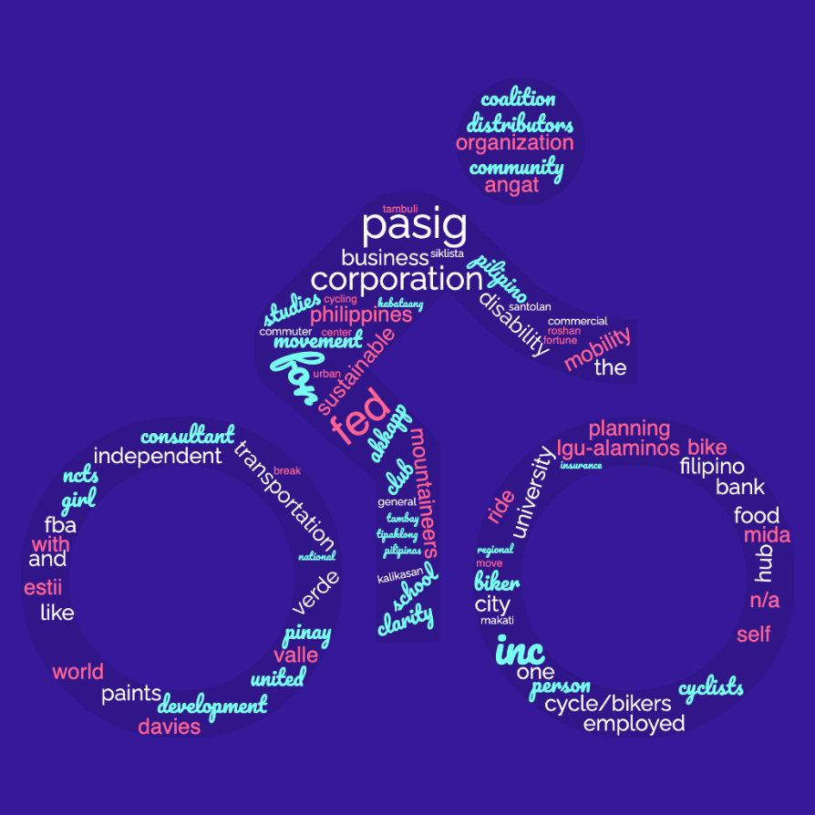
The word cloud below showcases the biking community and organizations that joined the online survey and F2F consultation to talk about the proposed public advisory cycling board.
It can be seen that numerous biking communities and organizations have joined the conversation. From independent groups, food-delivery riders, businesses, local riders, and bike-to-work advocates represented the discourse that occurred.

Thematic Analysis (Online and Public F2F Consultation)
In this analysis, the Gibbs Sampling Dirichlet Multinomial Mixture (GDSMM) was utilized to obtain topics from the textual and audio data. GDSDMM is a short text clustering model. The model groups words into a cluster like each other based on usage and meaning.
This analysis aims to determine the main concerns of the biking communities, the suggestions, and any underlying themes that can be obtained from the respondents' comments. Tables 1-7 present the top themes extracted from the text and audio data, in each article and section of the proposed public cycling advisory board.
Table 1: Top Themes Extracted from the comments on Articles 1 and 2
Article I: Outlines the general provisions including the title and purpose of the Cycling Advisory Board.
Article II: provides a definition of terms used by the Cycling Advisory Board.

Top Themes Obtained
The definition of bicycles should consider e-bikes
The usage of the phrase bicycle commuting should be more often
Avoid using 'Human-powered' as the sole definition for a bicycle
To widen the coverage of the ordinance: To include pedestrians and other users of Personal Mobility Devices (PMD)
e-bikes, scooters, and skateboards should be included in the ordinance"

Table 2: Top Themes Extracted from the comments on Article 3
Article III: Discusses the composition, appointment, and tenure of the Cycling Advisory Board.

Top Themes Obtained
at least one city council to be part of the board
assigning of the board through the election process
bike workers to be representative/board member
composition of boards should include social media influencers
bike shop owners, because bike shop owners have cars, hence they know the situation of both"
suggest not limiting the section3 to bike shop owners and including representatives from businesses in general
if a company representative will be included, no need to limit the appointment to a place of residence

Table 3: Top Themes Extracted from the comments on Article IV
Article IV outlines the responsibilities of the Cycling Advisory Board with regard to
Section 1: The Bike Lane Network Policy.
Section 2: The Bike Lane Network Implementation.
Section 3: Education and Enforcement of Cycling.
Section 4: Gathering Citizen Input on Cycling.
Top Themes Obtained
Implementation of programs that promotes safe spaces for bike commuters
co-existence of mechanical and e-bikes in bike lanes
The primary responsibility of the Advisory board should be focused on safety, connectivity, and segregated bicycle infrastructure
The suggestion of having an air-quality monitoring system
Promoting biking commuting and establishment of biking infrastructures, end-of-trip facilities, and parking

Table 4: Top Themes Extracted from the comments on Article V
Article V defines the officers of the Cycling Advisory Board.

Top Themes Obtained
Clarification on the sentence "The vice-chair succeeds the chair"
Who has the right to vote from the members of the board
The previous section did not mention that members would be called directors

Table 5: Top Themes Extracted from the comments on Article VI
Article VI defines the officers of the Cycling Advisory Board.

Top Themes Obtained
Monthly and quarterly meetings are suggested
Questions on the incentive per meeting; a bit too much
Suggest a secretary for the council
Indication of the source of the budget

Table 6: Top Themes Extracted from the comments on Article VII
Article VII provides the Final Provisions of the Cycling Advisory Board

Top Themes Obtained
none
none
none
All good

Table 7: Underlying Themes Obtained based on the other Comments
Topic # | Theme Title
1 | Bike lanes are not properly utilized.
2 | Bike cones are stolen and trashed
3 | Bike lane problem in Brgy. San Miguel
4 | Accessibility of bikes and bike lanes to the PWDs

As seen in Table 7, (4) underlying themes were observed from the comments of the participants. The first one states that the Bike lanes are not properly used, rather it is being used as parking spots and for other purposes as observed from the comments. This indicates a problem in the implementation of bike lanes in the city. Another theme obtained is that Bike cones are being stolen and trashed, this may imply security issues in the bike lanes as government-owned objects like bike cones can easily be stolen or disposed of. In the third theme, a specific problem was observed, in this theme, a specific location or barangay was mentioned indicating that there is a problem in the bike lanes of Brgy. San Miguel. Lastly, the access of bike lanes to the PWD, as there are challenges for the PWD when it comes to cycling in the city through bike lane routes. The highlighted themes observed from the analysis of the other comments can be used to design innovative and creative solutions that can help resolve the specific concerns mentioned.
Comparison of the Online and F2F consultation data:
Upon investigation and analysis of both data, it can be observed that the responses from online and public respondents are relatively the same. The comments, recommendations, and suggestions were closely related. Also, the main concerns were also mentioned in both survey approaches.

ANALYSTS FOR THIS REPORT:
Myron Darrel Montefalcon, Mideth Abisado
National University National University

Jay Rhald Padilla Ramon Rodriguez
National University National University
END OF REPORT
Revised: 11/17/2022

